Colleen Sheridan
Assignment 5 Inquiry Unit

Landform Inquiry Unit

Section I: Student Information

I am currently teaching in a K-4 resource room. The students in the room have a variety of disabilities. I worked with one student on the resource room caseload. The student that I worked with is a seven-year-old male of Arabic descent in second grade. Hussein is eligible for Special Education under Speech and Language Impairment. This student came to my elementary school from a public school in a nearby district.
The student is currently seen one-on-one in the resource room twice daily, totaling 5 hours and 45 minutes per week. In the resource room, the student works from a modified, lower level math curriculum. He also works on basic reading skills, and language skills. He is currently reading at a pre-primer level instructionally. It is hard to get the student engaged and motivated to do work, he often says that he cannot do the work and puts his head on his desk constantly. His general education teacher says that he cannot stay with the class in any subject taught. She gives him first grade math packets to work on, and beginner reader pattern books to read during silent reading time. A discussion regarding a change in placement has been taking place throughout the school year. He is not making as much progress as the special education teacher, general education teacher, and speech and language pathologist would like to see. The team is considering suggesting a change of placement to an Academic Resource Program in a cross categorical classroom. He was given a full evaluation last year and test results are shown below:

Test | Score | %tile
Curriculum Based Writing Measure | 0 | -
Pre-primer BRI | Frustration- word recognition and comprehension | -
Dolch Pre-primer | 13/39 | -
2nd grade math concepts and applications probe | 3 (raw score) | 16th %tile
Full scale IQ | 84 | 14th &tile

Section II: Planning My Unit:

The first thing I did to plan my unit was I met with the student’s second grade classroom teacher. I wanted to pick a subject area to do the project on that the student was not used to working on in the resource room, so it was something different and exciting for him. Our elementary school is a PYP, or Primary Years Programme school. The PYP curriculum consists of inquiry-based social studies and science units. Classes spend about six weeks on a social studies unit then the next six weeks are spent on a science unit. I found out that the upcoming science unit was going to be on landforms. I also looked up second grade Grade Level Content Expectation standards, and found one that corresponded with the lesson, “E.SE.02.21 Describe the major landforms of the surface of the Earth (mountains, plains, plateaus, valleys, hills). “I asked the teacher if I could do an inquiry unit with her student in the resource room on one type of landform. The students in Hussein’s second grade class were doing the same project. His teacher said it would be nice for me to do it with him because he needs a lot of extra support.
The next thing my CT and I did was figure out how much time should be allotted to working on this project. We agreed that we would do it for 15 minutes each day, alternating between his reading time and his math time.
After I had figured out our research subject, and the time that would be spent doing it, I did some research on the internet for good websites on landforms, I also checked out different books on landforms, as well as borrowed books from the classroom teacher.

Section III: Planning, Activating and Building Background Knowledge

Day One: How do researchers find information?
- Discuss different methods of doing research (reading books, investigating, finding information on the internet)
- Explain to the student that we are going to be science researchers. Tell him that we are going to read and write about a landform.
- Do research on what a landform is (Website: http://www.kidsgeo.com/geology-for-kids/0031-what-are-landforms.php)

Section IV: Teaching Strategies for Gathering, Recording, and Organizing Information (2.5 points)

Day Two- Gathering, Recording, and Organizing Information
- Do research on different kinds of landforms http://www.enchantedlearning.com/geography/landforms/glossary.shtml
- Discuss why researchers use graphic organizers
- Fill in graphic organizer of different kinds of landforms and their attributes
- Pick one landform from the graphic organizer that we will commit to doing research on
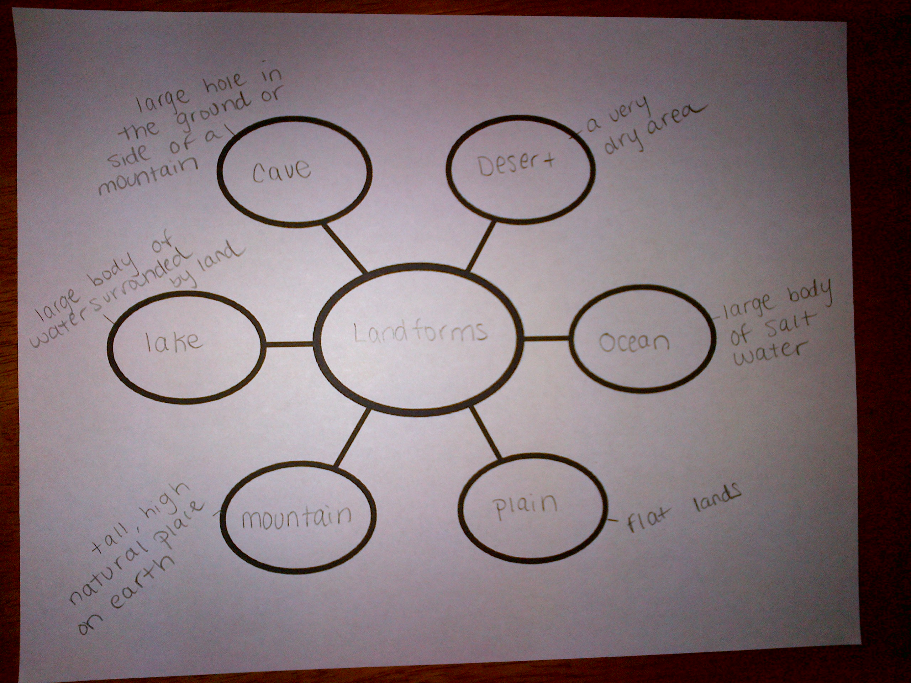

Day Three
- Visit the school library together
- Check out books on landforms and deserts
- Discuss the importance of finding a variety of sources to use for doing research
- Define what a landform is
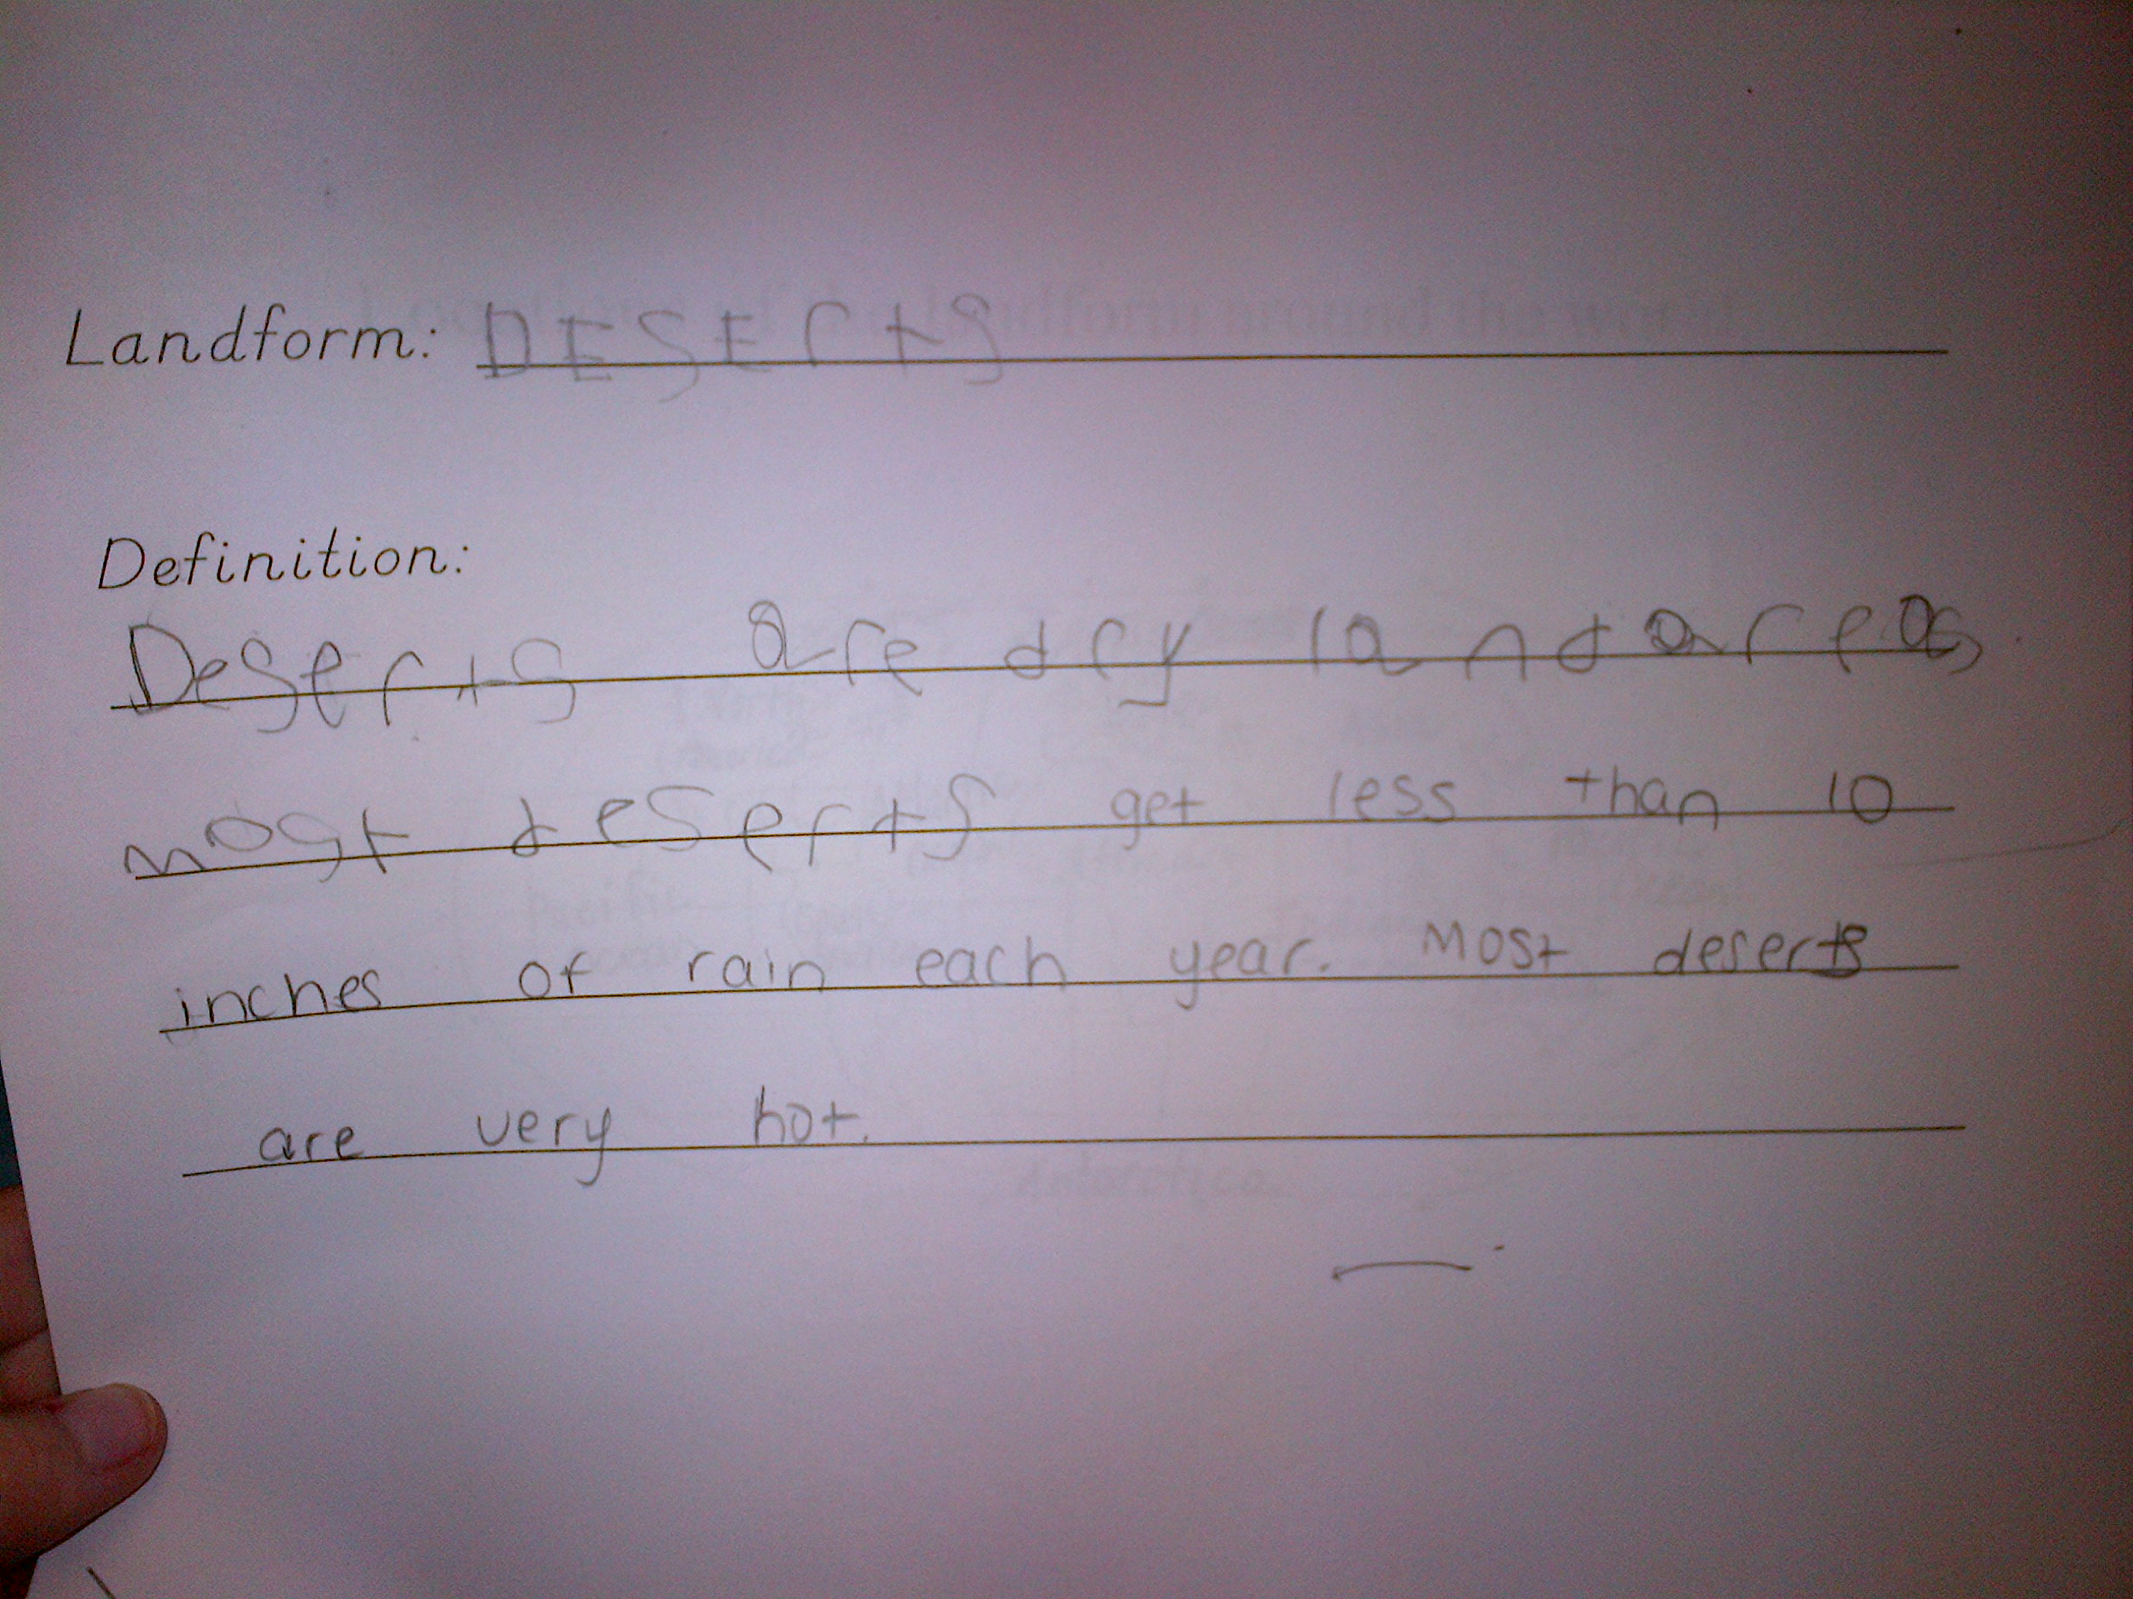

Day Four
- [Reading Lesson]
- Teach the different elements of a nonfiction book (Title, Table of Contents, Glossary)
- Model reading a section or paragraph of the book, and picking out the most important details for our research purposes using the highlight-it strategy
- Record new facts that we learned from using the highlight-it strategy and discuss our learning
- [See Reading Lesson]

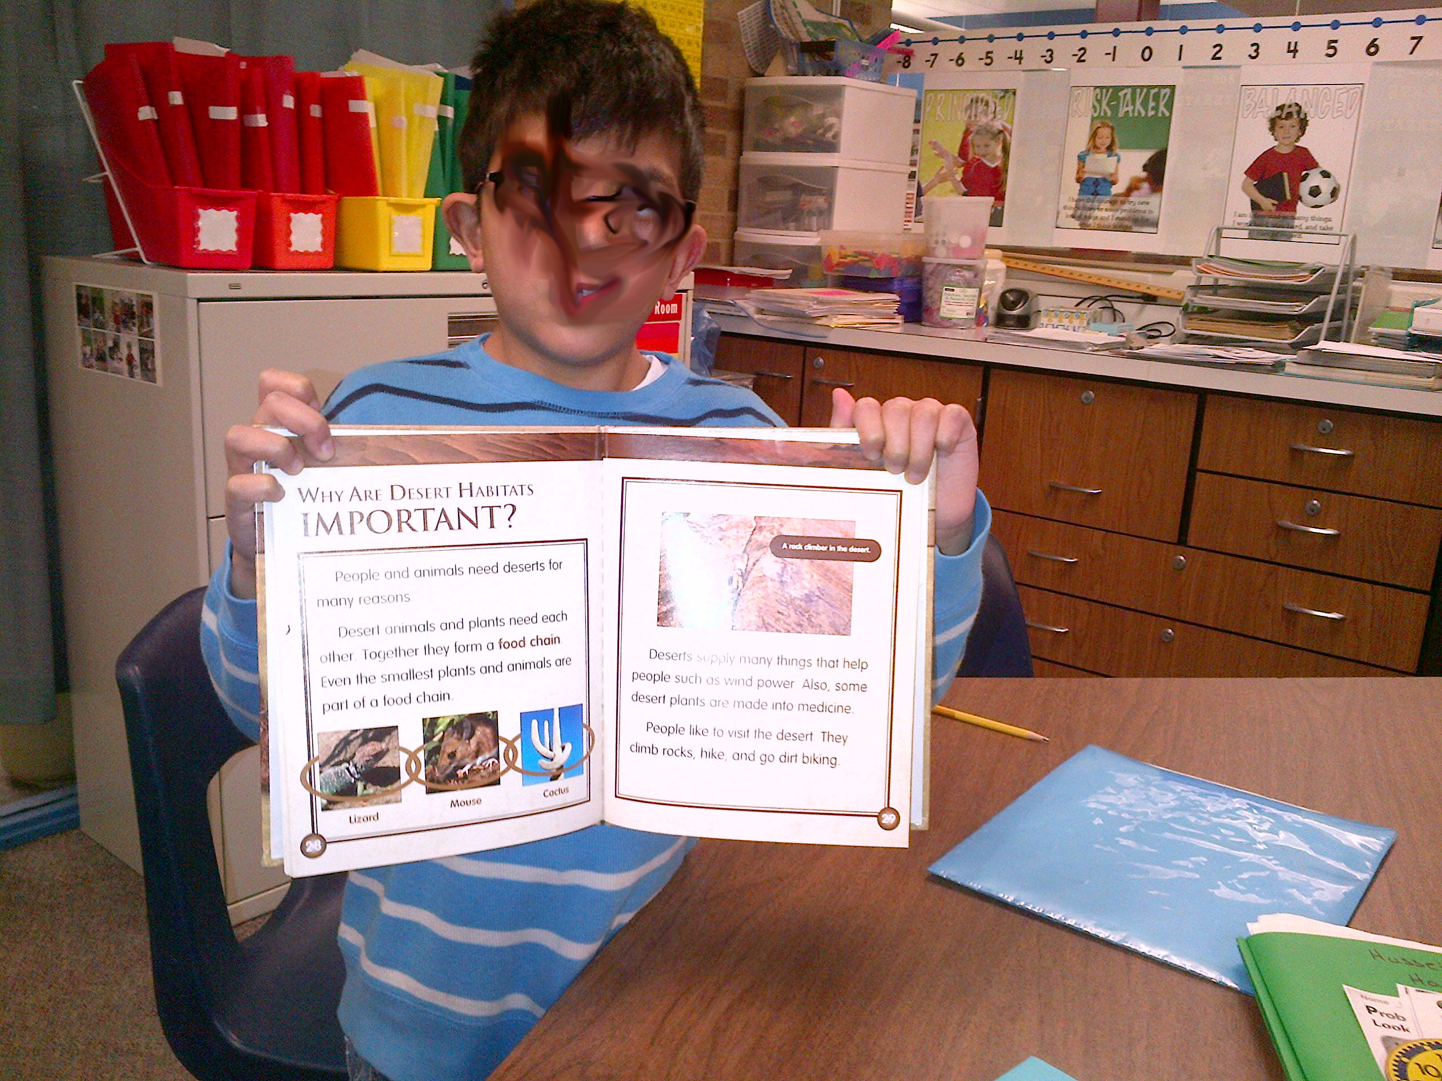

Section V: Building Additional Background Knowledge (2.5 points)

Day Five-Seven: Building Additional Background Knowledge
- Review our reading lesson from the day before
- Look at all of the information that we learned from doing the highlight-it strategy, and continue to look for more information about Deserts
- Answer questions about landforms
  - How does the landform affect the people living around it?
  - What other interesting facts did I learn about my landform?
- Work together to answer questions and put the papers in landform folder
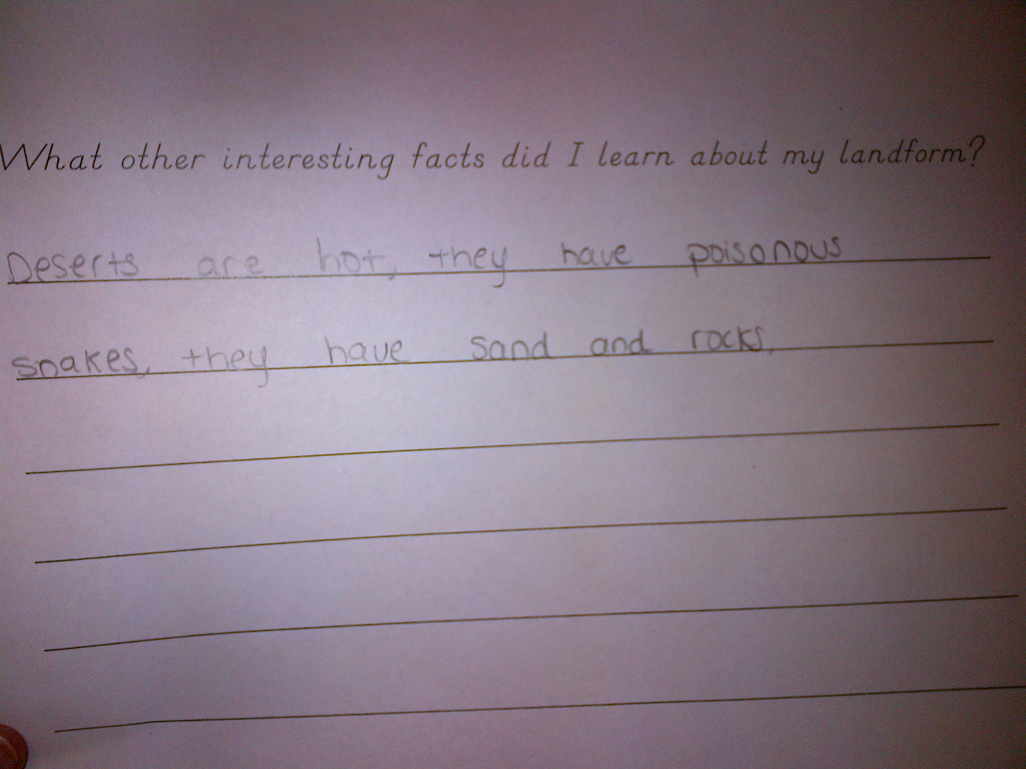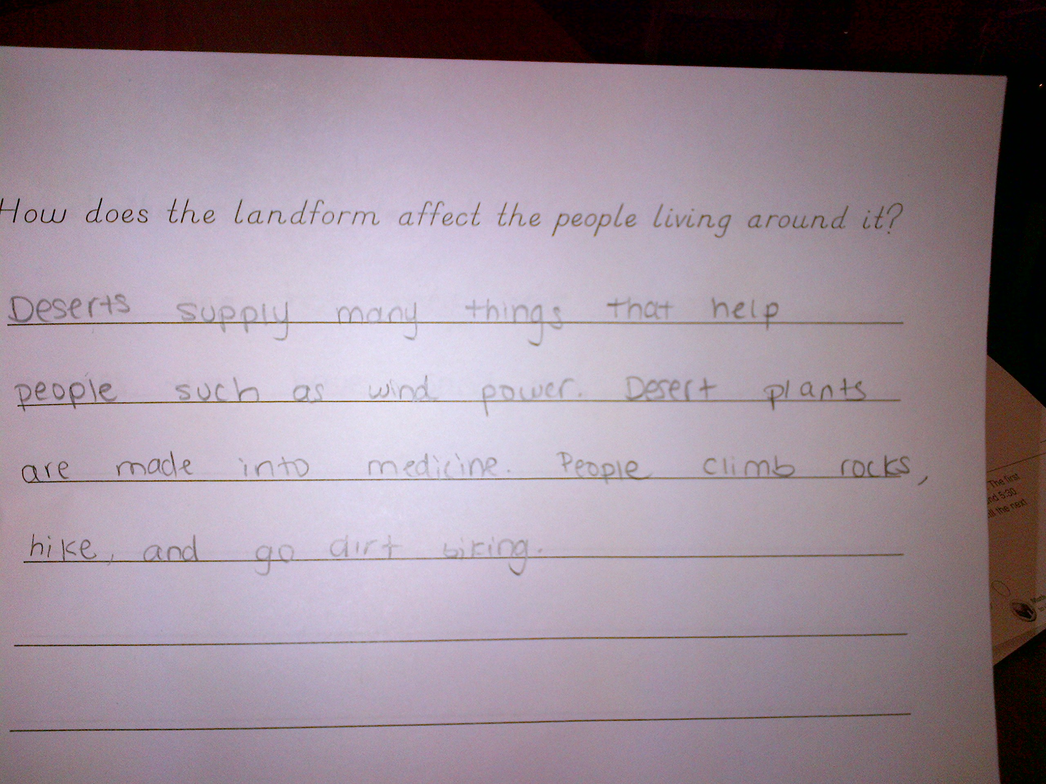

Day Eight and Nine: Drafting, Editing, Revising Writing
- [See Writing Lesson]
- Introduce student to POWER and supply an organizer or anchor chart
- Plan and organize think sheets
- Model and Teach how to use the Hamburger organizer to plan and organize our writing
- Create a model paragraph on a different landform
- Student will draft a paragraph about Deserts (write think sheet)
- Model how to edit and revise my paragraph
- Have student edit and revise his paragraph (edit, revise think sheets)

Section VI: Drafting, Editing, and Revising Final Product(s) (2.5 points)
Day Ten and Eleven: Drafting, Editing, and Revising Final Product(s)
- Introduce final project. Student will have to create a small scale model of his landform using different materials
- Each member of his class was assigned the same project
- Review student’s flipbook and the notes we took about deserts together. Talk about what his landform is going to look like and include
- Make a list together
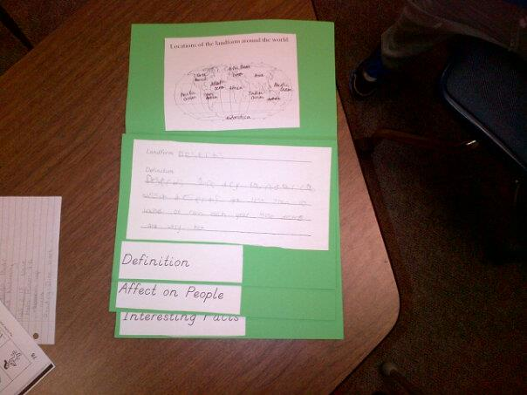

Section VII: Presenting or “Publishing” Final Product(s)/Assessment and Accountability for Learning (2.5 points)
Day Twelve: Presenting or “Publishing” Final Product(s)/Assessment and Accountability for Learning
- Each student in his second grade class shows their project. Parents, teachers and other students see the projects
- Students give a small summary of what they have learned
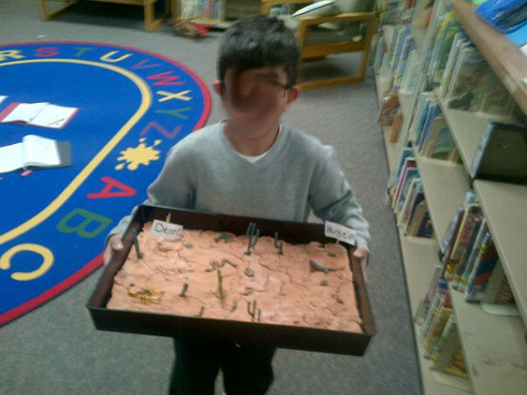

Section VIII: Reflection and Critique of Unit (narrative of strengths, weaknesses, and next steps) (2.5 points)

I really enjoyed working on this inquiry project with Hussein. When I initially decided to work with Hussein, I was a little apprehensive because I know that he is not always motivated to do work. However, I am so glad I picked him because I learned different ways to get him motivated to work. Working on something besides reading and math was motivating for Hussein. It was nice for him to be able to work on something else in the resource room. He took a lot of ownership in his learning. When I explained that he was going to be an expert on Deserts, he got excited. When he would tell me facts that he knew about Deserts, I could tell that he was proud of all of the knowledge that he had. Doing research on the computer was also fun for Hussein. We do not integrate enough technology in the resource room in our lessons, so letting Hussein work on the computer was exciting for him, and it motivated him. The highlight-it reading lesson was very successful. Hussein enjoyed using a highlighter on texts, and having the cue card available made him successful at using the strategy. He was excited to tell me about the new knowledge that he was learning about Deserts. I think something that made the reading lesson successful was my use of modeling and think alouds. I do not think Hussein would have been able to successfully use the highlight-it strategy in the text without me doing a lot of modeling on the proper technique of highlighting a text. It was also important for me to think aloud as I was doing both the reading and writing lessons, as well as during the other activities throughout the inquiry project. Making my thinking visible to Hussein helped him understand exactly what we were doing during each phase of the lesson. Having Hussein write information on graphic organizers throughout the unit made his thinking visible as well. He wrote down answers to questions on pieces of paper throughout the inquiry unit, and he was also able to successfully complete his flipbook. We also made lists of information that he knew about deserts before the reading lesson, and after. This helped Hussein see all of the different things he had learned. When it came time to do our writing lesson, Hussein already had a wealth of information about Deserts, making him motivated for writing, which is something he is usually not motivated to do. I think the structure of writing using POWER also helped to break down the writing bit by bit, instead of trying to do just jump right into writing a paragraph. Using graphic organizers for all elements of the inquiry unit helped Hussein successfully complete each activity. One day during the inquiry project, Hussein said, “I am going to teach my mom all about Deserts when I get home.” I could tell that he enjoyed the fact that he knew so much about a particular topic.
Since I knew that Hussein had a hard time getting work done, I feel like I did a lot of work for him that he might have been able to do on his own. Although I think that scaffolding him was a strength of my lesson, I also think it was a weakness at times. Because of time restraints, I ended up doing a lot of writing for him. He had to answer some questions on paper that we made into a flipbook, but I wrote most of his answers down as he told me what to write. I think next time I would provide more time, and make him do a little more writing. Sometimes he would complain and say that he “couldn’t write”. I think I could have pushed him a little more to try his hardest to write the information down. I think that if he completed the flipbook with his own writing, he would take even more ownership of the work he had done. Next time I would explore even more texts to see if he could transfer the highlight-it reading strategy to a variety of texts. It would be interesting to see if he could use the strategy on a different landform that he was not as familiar with. If I had time, I would explore another landform with Hussein to see if he would transfer his learning from this unit to learning something new.
Overall, I had a really good experience teaching this unit. I learned a lot as a teacher. I found different activities to do to motivate an otherwise unmotivated student. I could clearly see the importance of modeling and doing think alouds. I got experience using the POWER method to teach writing, and the highlight-it strategy to teach reading an expository text. I will definitely use exciting inquiry based units to teach my students in my own classroom.

